

“ A CASE STUDY ON HOUSING PROJECT FOR US-BASED HOUSING COMPANY NAMED SURPRISE HOUSING HAS DECIDED TO ENTER THE AUSTRALIAN MARKET”

Submitted by:

**RAHUL AHUJA**

**INTRODUCTION**

* Business Problem

Houses are one of the necessary needs of each and every person around the globe and therefore housing and real estate market is one of the markets which are one of the major contributors in the world’s economy. It is a very large market and there are various companies working in the domain. Data science comes as a very important tool to solve problems in the domain to help the companies increase their overall revenue, profits, improving their marketing strategies and focusing on changing trends in house sales and purchases. Predictive modeling, Market mix modeling, recommendation systems are some of the machine learning techniques used for achieving the business goals for housing companies. Our problem is related to one such housing company.

* Conceptual Background of the Domain Problem

A US-based housing company named Surprise Housing has decided to enter the Australian market. The company uses data analytics to purchase houses at a price below their actual values and flip them at a higher price. For the same  
purpose, the company has collected a data set from the sale of houses in Australia. The data is provided in the CSV file below. The company is looking at prospective properties to buy houses to enter the market.

* Motivation for the Problem Undertaken

Below is the points/reasons for the below problem undertaken:

* To build a model using Machine Learning in order to predict the actual value of the prospective properties and decide whether to invest in them or not.
* To find out the variables are important to predict the price of variable?
* How do these variables describe the price of the house?

**Analytical Problem Framing**

* Mathematical/ Analytical Modeling of the Problem

The paper made exploratory research on the need, Problems, influencing factors in business of the in the Australian market. The company use data analytics to purchase houses at a price below their actual values and flip them at a higher price. For the same purpose, the company has collected a data set from the sale of houses in Australia This study based on the comprehensive review of the literature, theories and models have been carried out to propose the models for understanding the buying and selling patterns of the houses so that the prices of the houses have been evaluated and the maximum profits can be earned out of it. There are many factors like: Condition of sale of house, amenities, size of the house, Physical location of neighborhood, age of house etc.

* Data Sources and their formats
* Two datasets are being provided to you (test.csv, train.csv). You will train on   
   train.csv dataset and predict on test.csv file.
* Data contains 1460 entries each having 81 variables.
* Data contains Null values.
* Data contains numerical as well as categorical variable.



|  |  |  |  |  |
| --- | --- | --- | --- | --- |
| **Column Name** | **Data Type** |  | **Column Name** | **Data Type** |
| Id | int64 |  | Heating | object |
| MSSubClass | int64 |  | HeatingQC | object |
| MSZoning | object |  | CentralAir | object |
| LotFrontage | float64 |  | Electrical | object |
| LotArea | int64 |  | 1stFlrSF | int64 |
| Street | object |  | 2ndFlrSF | int64 |
| Alley | object |  | LowQualFinSF | int64 |
| LotShape | object |  | GrLivArea | int64 |
| LandContour | object |  | BsmtFullBath | int64 |
| Utilities | object |  | BsmtHalfBath | int64 |
| LotConfig | object |  | FullBath | int64 |
| LandSlope | object |  | HalfBath | int64 |
| Neighborhood | object |  | BedroomAbvGr | int64 |
| Condition1 | object |  | KitchenAbvGr | int64 |
| Condition2 | object |  | KitchenQual | object |
| BldgType | object |  | TotRmsAbvGrd | int64 |
| HouseStyle | object |  | Functional | object |
| OverallQual | int64 |  | Fireplaces | int64 |
| OverallCond | int64 |  | FireplaceQu | object |
| YearBuilt | int64 |  | GarageType | object |
| YearRemodAdd | int64 |  | GarageYrBlt | float64 |
| RoofStyle | object |  | GarageFinish | object |
| RoofMatl | object |  | GarageCars | int64 |
| Exterior1st | object |  | GarageArea | int64 |
| Exterior2nd | object |  | GarageQual | object |
| MasVnrType | object |  | GarageCond | object |
| MasVnrArea | float64 |  | PavedDrive | object |
| ExterQual | object |  | WoodDeckSF | int64 |
| ExterCond | object |  | OpenPorchSF | int64 |
| Foundation | object |  | EnclosedPorch | int64 |
| BsmtQual | object |  | 3SsnPorch | int64 |
| BsmtCond | object |  | ScreenPorch | int64 |
| BsmtExposure | object |  | PoolArea | int64 |
| BsmtFinType1 | object |  | PoolQC | object |
| BsmtFinSF1 | int64 |  | Fence | object |
| BsmtFinType2 | object |  | MiscFeature | object |
| BsmtFinSF2 | int64 |  | MiscVal | int64 |
| BsmtUnfSF | int64 |  | MoSold | int64 |
| TotalBsmtSF | int64 |  | YrSold | int64 |
|  |  |  | SaleType | object |
|  |  |  | SaleCondition | object |
|  |  |  | SalePrice | int64 |

* Data Pre-processing Done

Below are the steps taking for pre-processing and cleaning the data for the  
 analysis.

* The data has been provided in excel sheet for both training and the prediction.
* The data is on both object and the integer/float format
* The train data has total 1168 rows and 81 columns and test data has 292 rows and 80 columns
* There are null values in both train and test sheet.
* The null value has been replaced with mean/Average and the given details.
* Most of the data/columns are object type so we have to convert them into the integer format.
* The outliers are available in the data which has been removed before processing the Model.
* Rectified the string data for visualization.
* We need to drop id columns as it add no value in prediction.
* Used Label Encoder for converting the object data into Integer for further analysis.
* Used standard scaler to standardized the data
* Data Inputs- Logic- Output Relationships

The data has been categorized into two and that has been given x and y

y data contains the columns (Sale Price of the house).

x data contains the complete data except the Sale Price column which will help to understand the relationship of all the other columns with each other and help to predict the value of y (Sale Price of the house).

**Model/s Development and Evaluation**

* Identification of possible problem-solving approaches (methods)

Visualizations

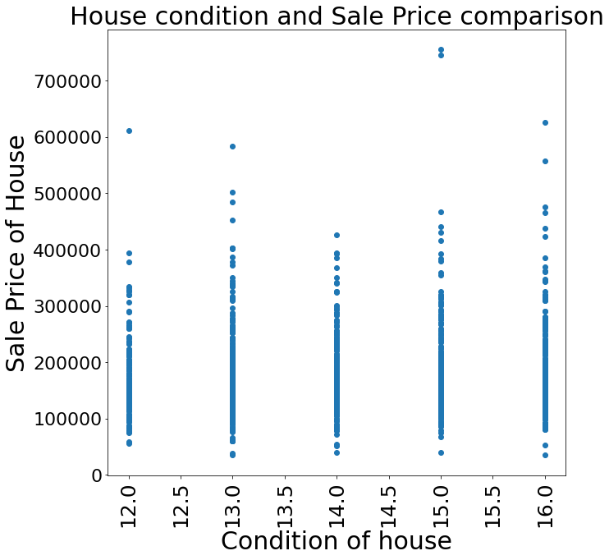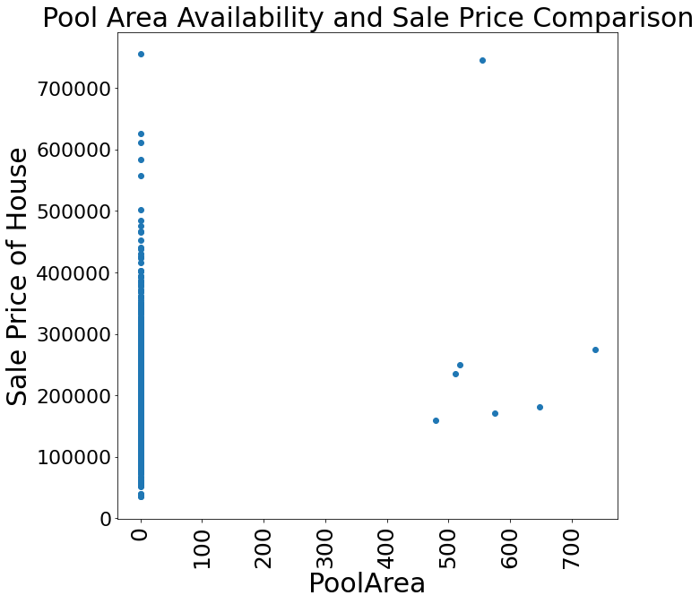

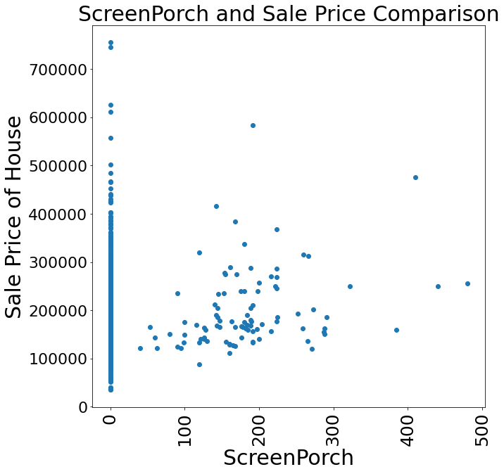 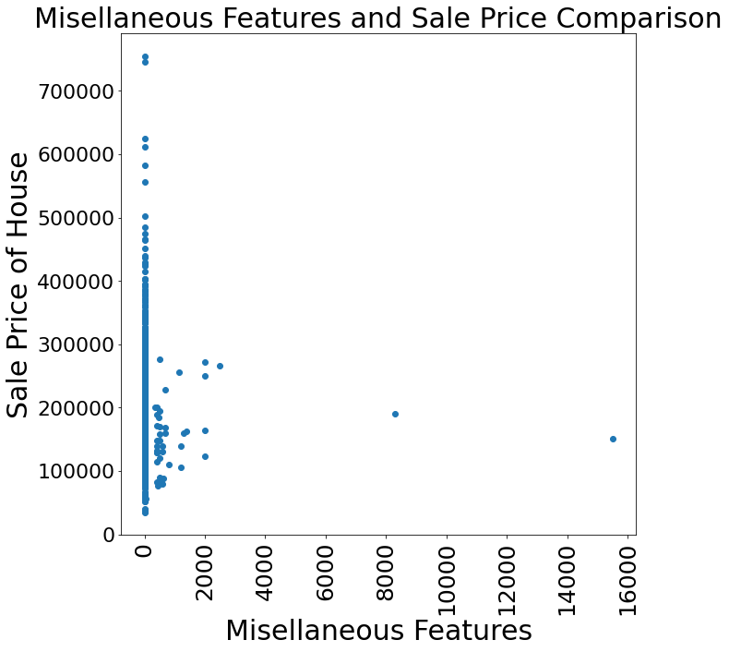

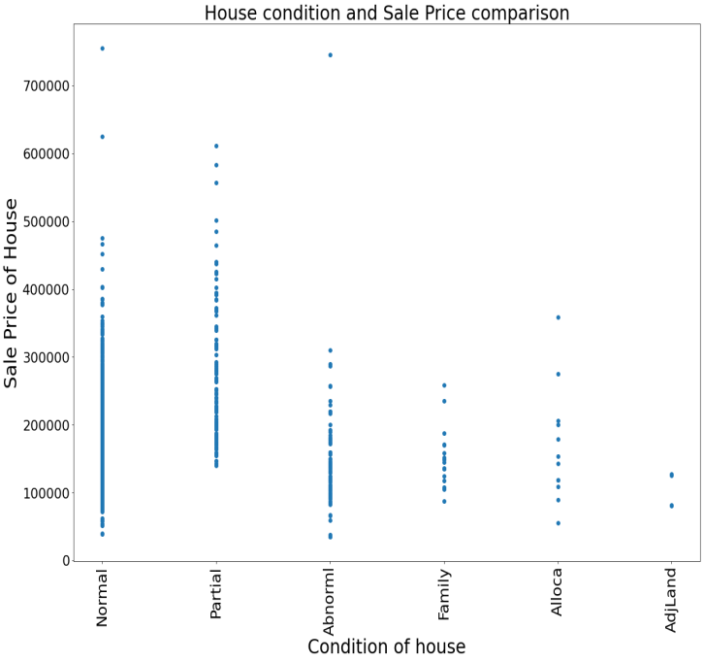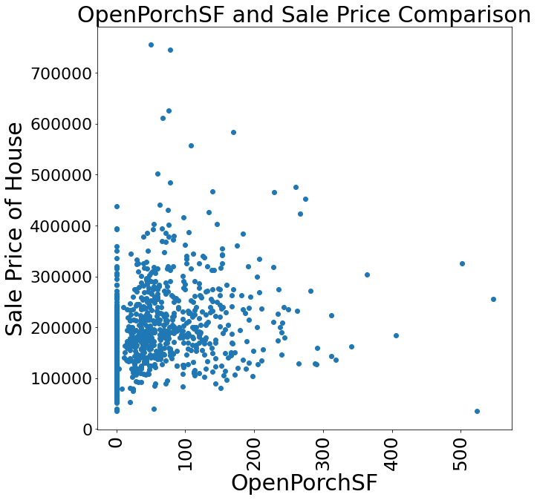

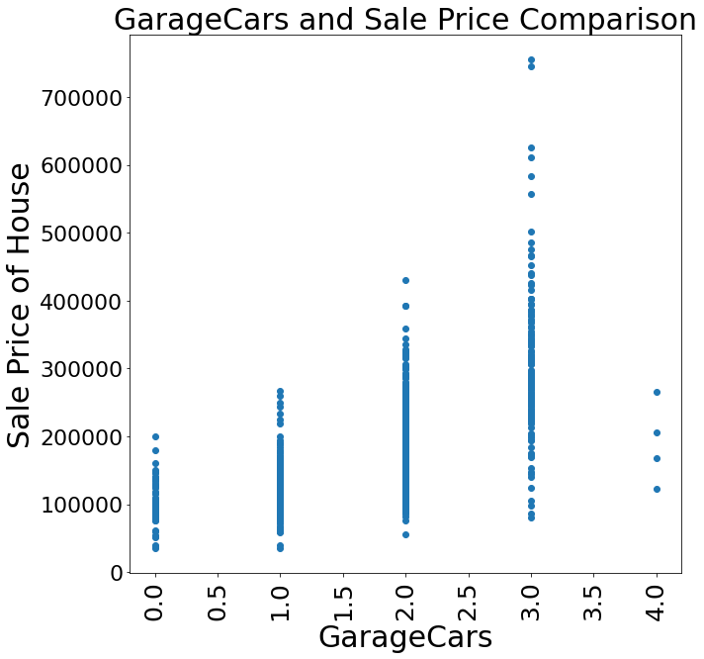 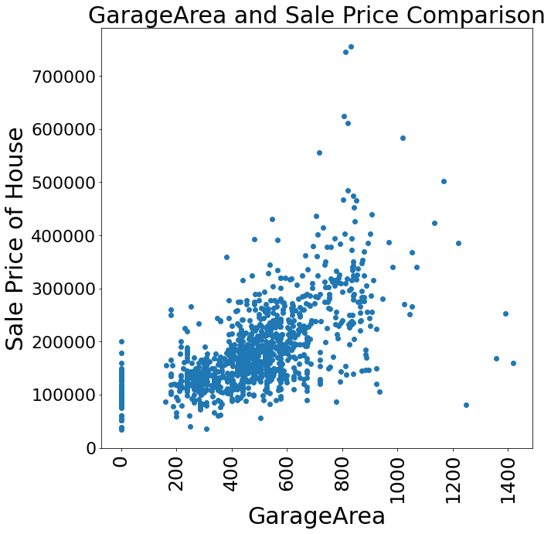

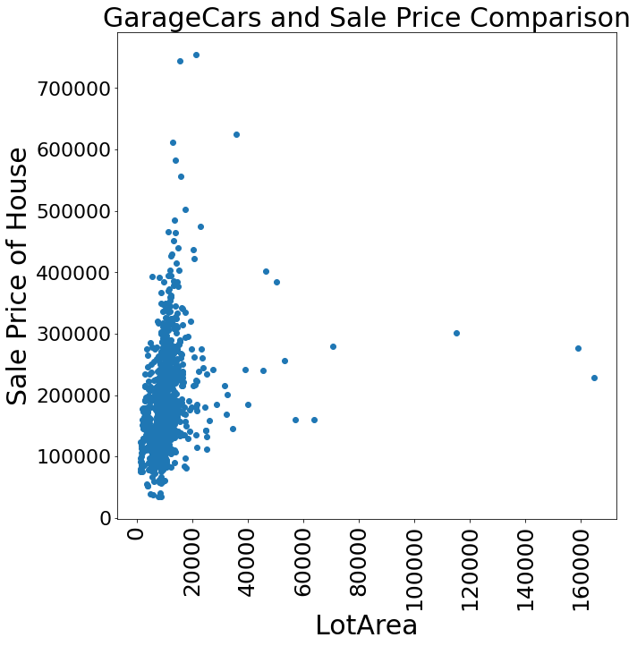 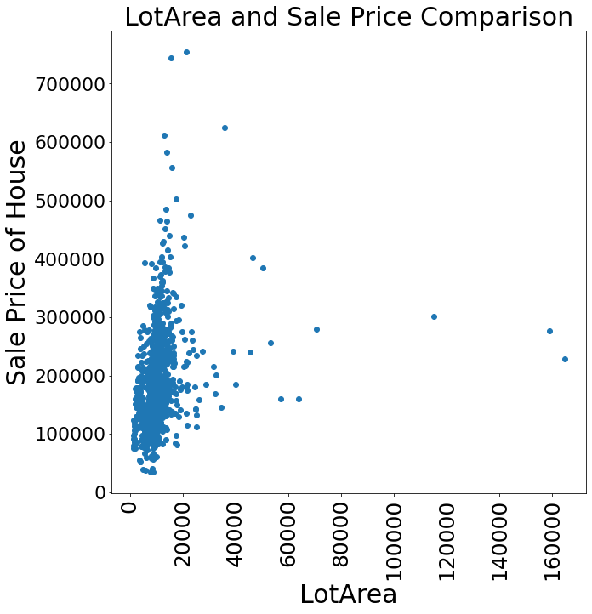

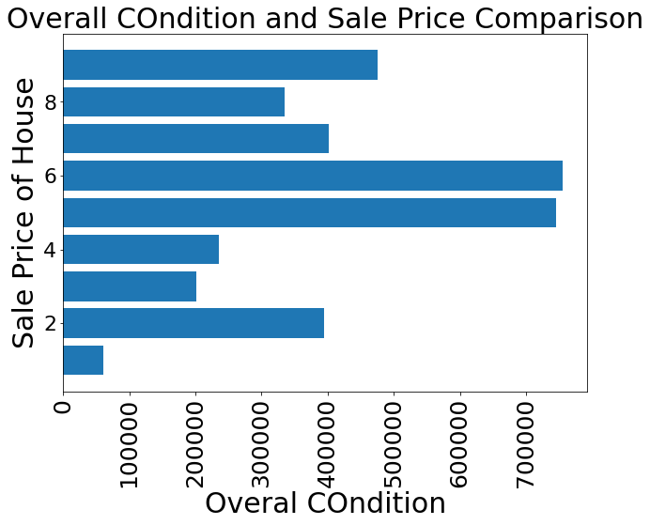 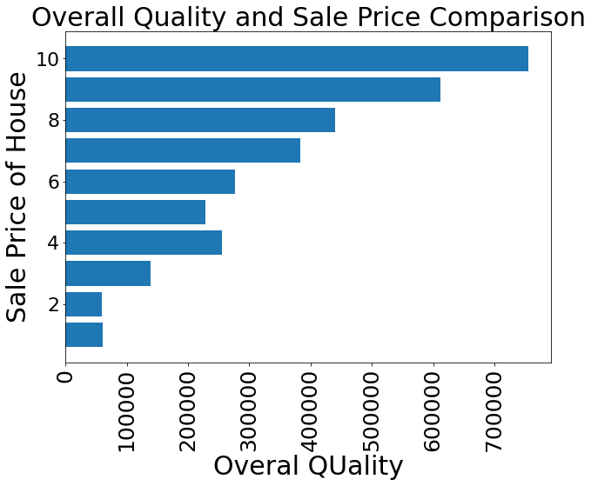

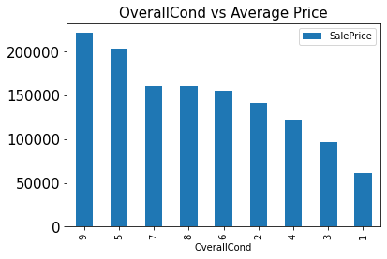 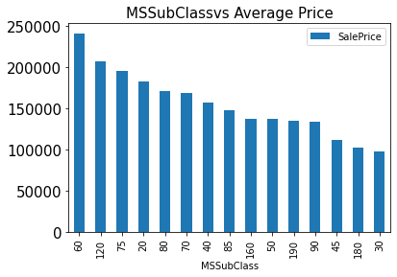

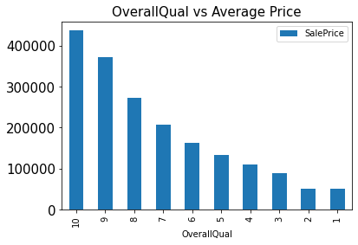 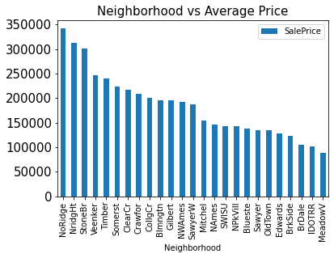

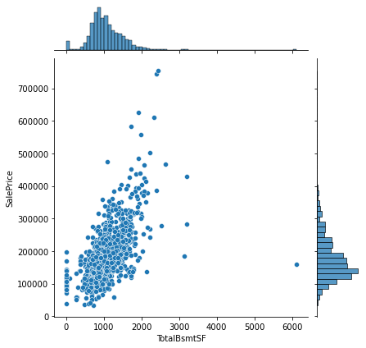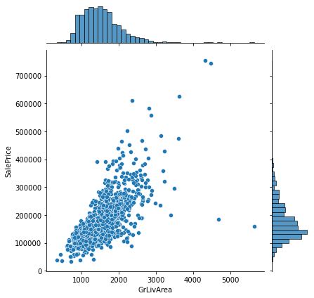

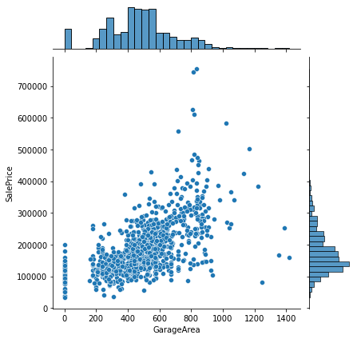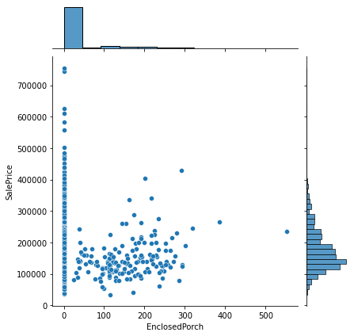

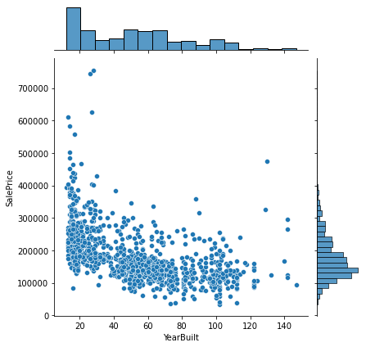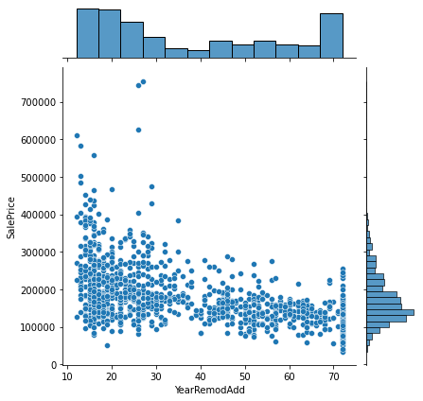

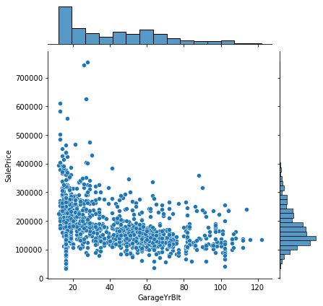

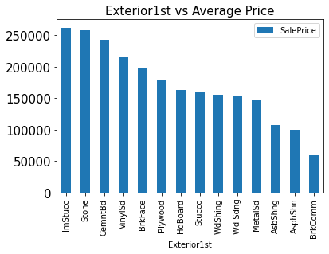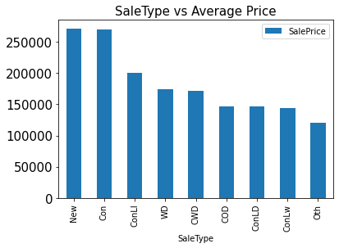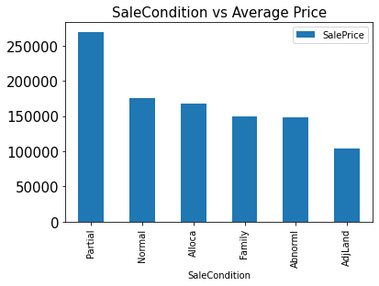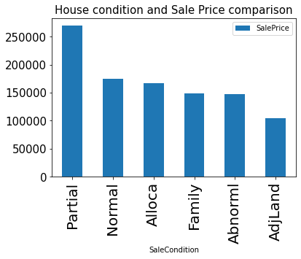

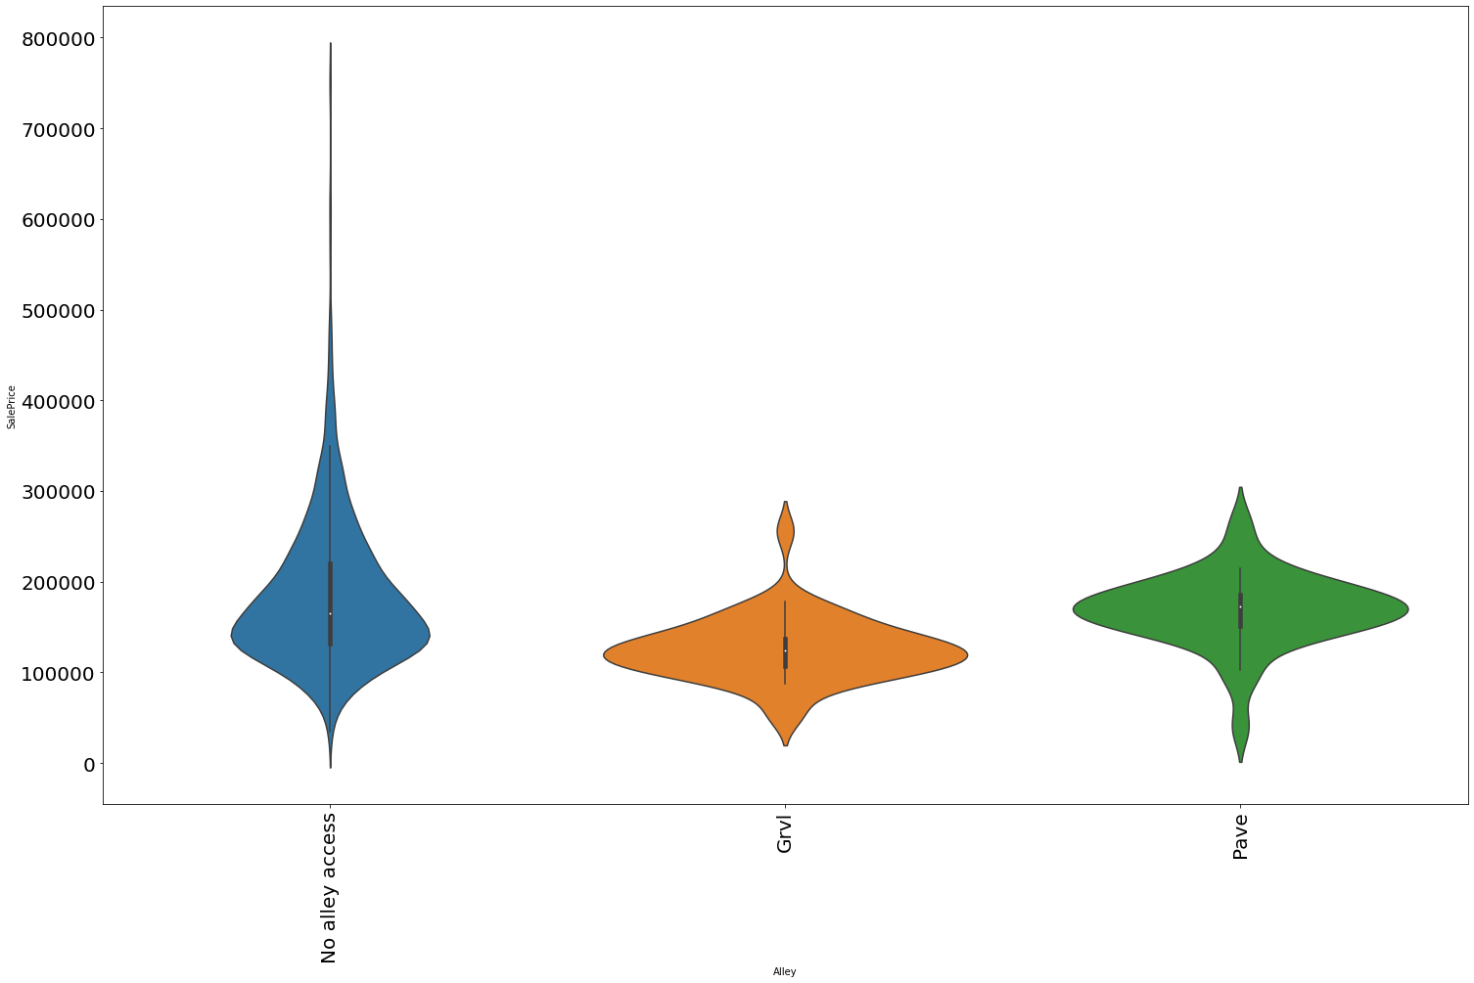

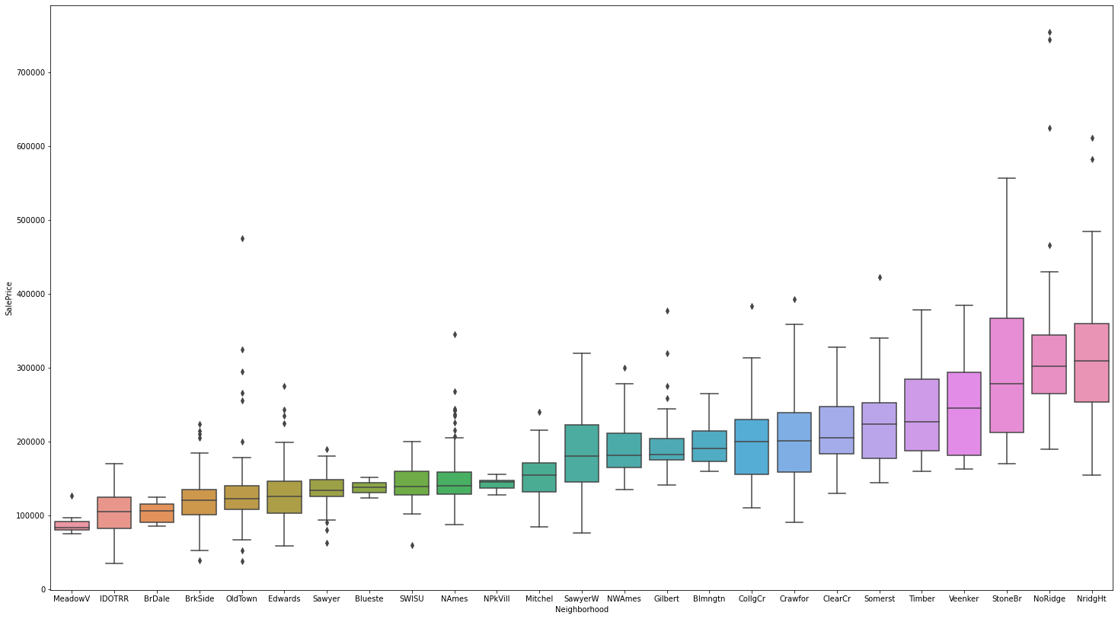

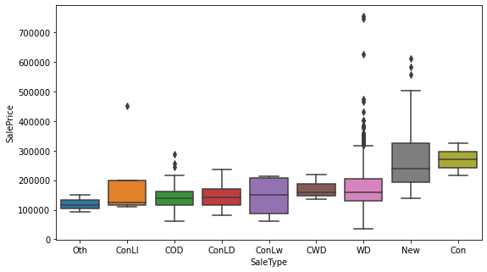

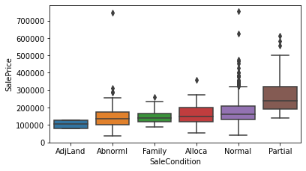

**Outliers:-**

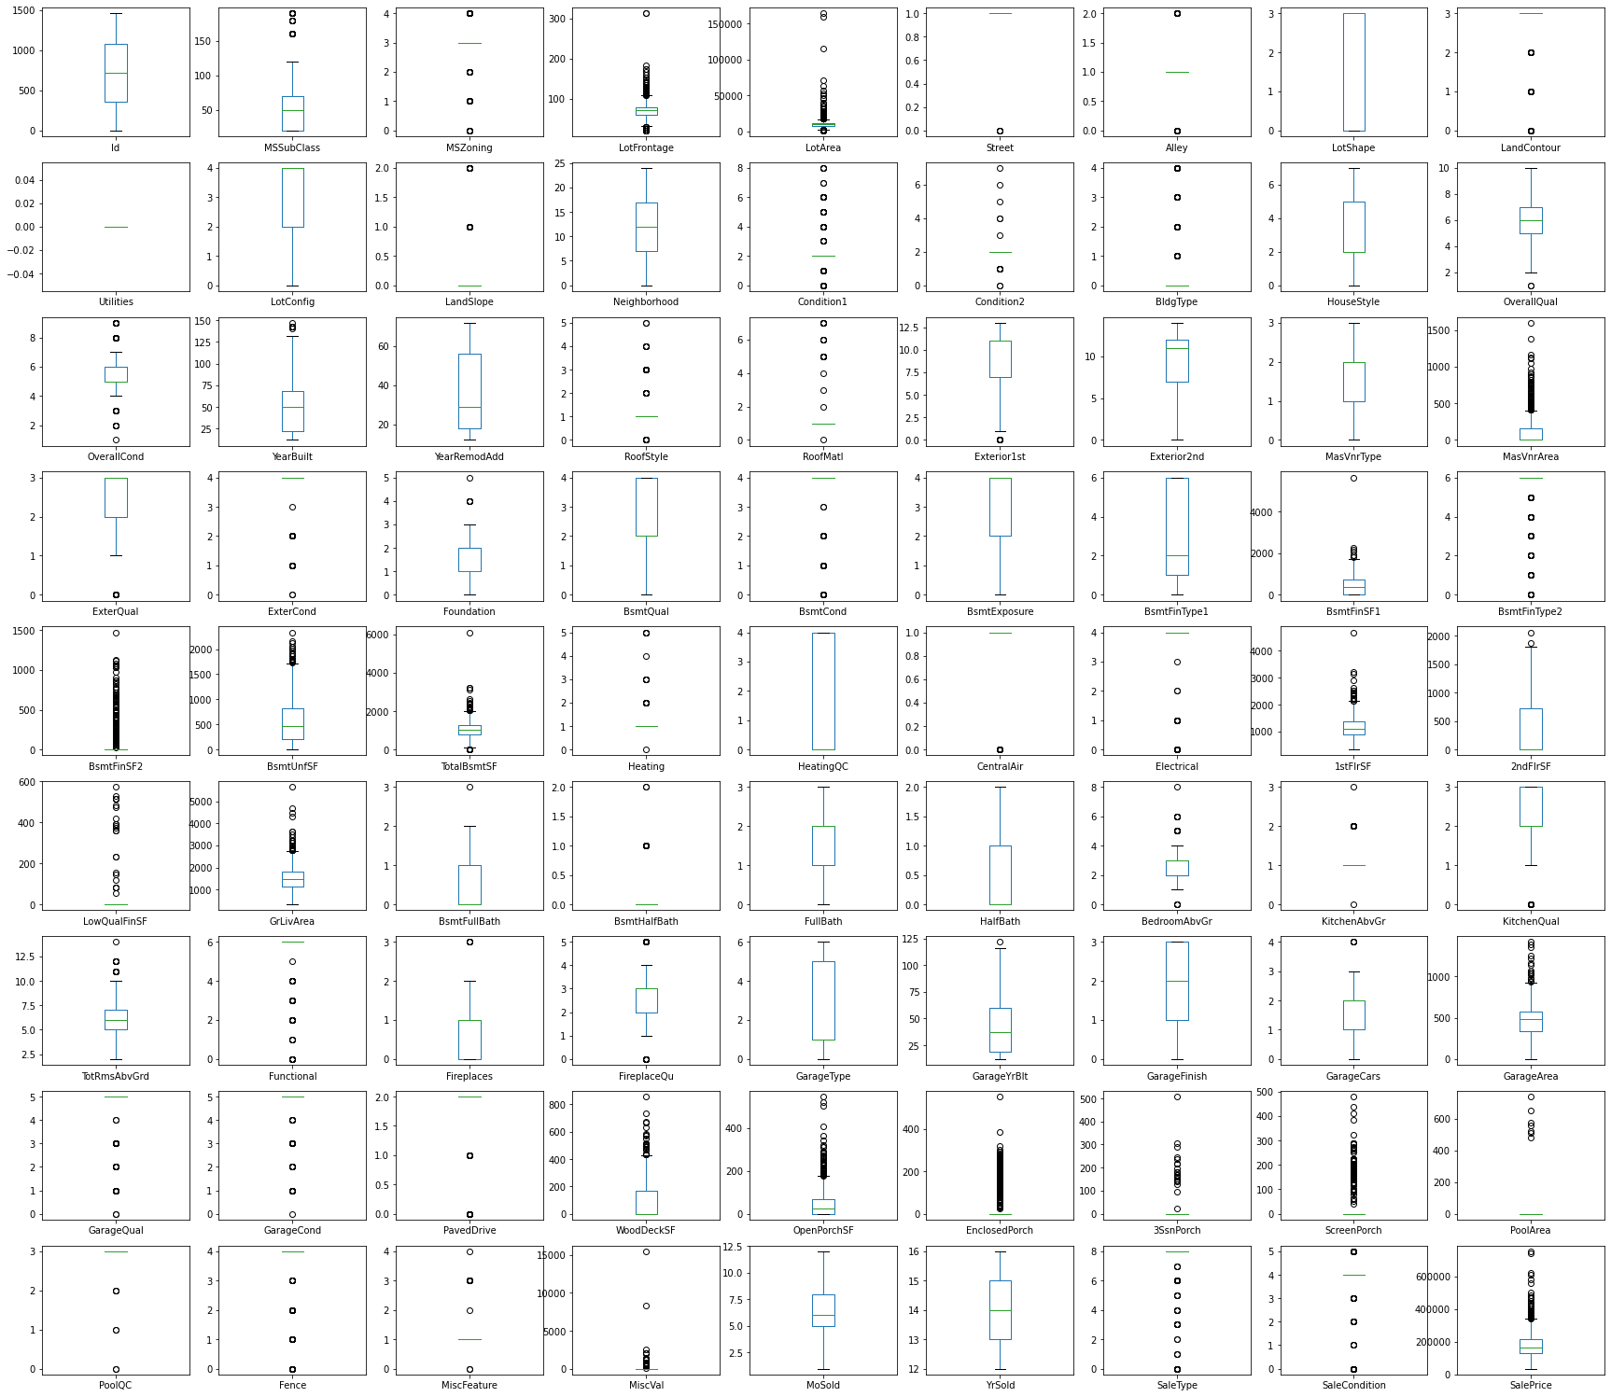

* Key Findings of the study

1. The Counting and the price of 1-STORY 1946 & NEWER ALL STYLES are high in comparison to other MSSubClass
2. The availability of the house in Residential Low Density is high but prices of Floating Village Residential house are high.
3. The lot size of 21535 square feet has the high prices and the availability of 9600 square feet is high.
4. The Overall quality index and the Sale Price and the positive correlation.
5. The Overall condition index and the Sale Price and the positive correlation.
6. The Prices of the Excellent quality material is high but the availability of houses built with fair material is high.

* Conclusions of the Study

Below is the conclusion.

After refining the data we have tested different models like Linear Regression,   
 SVR, Decision Tree Regressor, K Neighbors Regressor, Random Forest Regressor,   
 Ada Boost Regressor and the Gradient Boosting Regressor and after doing the   
 hypermetric tuning we have found that the Random Forest Regressor has   
 provided the best result.   
 The score of the same is mention below.



**Below is the actual data v/s prediction data**

